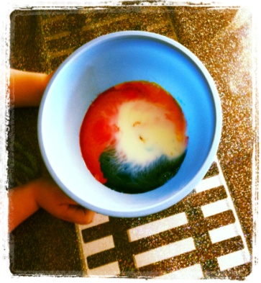
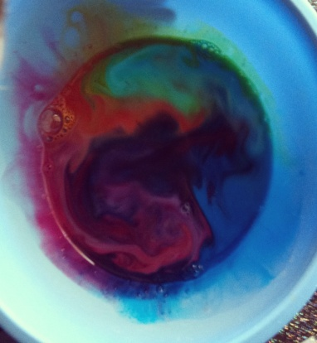

Whilst changing Ethan I began to sing the ‘rainbow song’ Ethan already knew this song and instantly began to sing along “Red and yellow and pink and green, purple and orange and blue, I can see a rainbow, see a rainbow, do you see a rainbow too?”
Later in the day after we had done some drawing Ethan looked up at me and said “Rainbow song?” He had gathered all the coloured pencils needed to make the rainbow. We started the song again, this time Ethan picking up or pointing to which colour in the song we were up to. He was very pleased with himself, we high fived every time we finished the song before starting again.

Link to Early Years Learning Framework outcomes;
1- Children have a strong sense of identity
- Initiate interactions and conversations with trusted educators
- Initiate joy in play
- Recognise individual achievements and achievements of others
3- Children have a strong sense of wellbeing
- Share humour, happiness and satisfaction
4- Children and confident and involved learners
- Follow and extend their own interests with enthusiasm, energy and concentration
- Initiate and contribute to play experiences emerging their own ideas
5- Children are effective communicators
- Engage in enjoyable interactions using verbal and non- verbal language

Extension ideas;
To extend on Ethan’s learning experience I will research ‘rainbow experiments’ to create an age appropriate science/creative experience and find some books about colours that will challenge and support Ethan’s interest in rainbows.

Date of implementation: 08/12/2011

